***NAME – KHUSHI PANWAR, khushipanwar26@gmail.com***

***ROLL NO – 33***

***C++ PRACTICAL ASSIGNMENT – 16 DEC 2021***

1. **WAP including the logical operators & mixed data expressions:**

#include<iostream>

#include<iomanip>

using namespace std;

int main(){

int x;

double y;

char ch='A';

double z;

bool b=true;

cout<<"\t* USING static_cast<int>(...)*"<<endl;

cout<<"ASCII value of "<<ch<<" is "<<static_cast<int>(ch)<<endl;

cout<<"Enter the value of x and y: ";

cin>>x>>y;

cout<<showpoint;

cout<<setw(30)<<"\n * EVALUATING EXPRESSIONS *"<<endl;

z=x++%4;

cout<<"\nz=x++%4"<<endl;

cout<<"\t -> NEW VALUE of z="<<z<<endl;

z=x*y+ch;

cout<<"\nz=x*y+ch"<<endl;

cout<<"\t -> z="<<z<<endl;

z=x/y+b;

cout<<"- BOOL b="<<b<<endl;

cout<<"- z=x/y+b"<<endl;

cout<<"\t-> NEW VALUE of z="<<z<<endl;

cout<<setw(30)<<"\n * EVALUATING LOGIC EXPRESSIONS *"<<endl;

b=(x>y) || ++x;

cout<<"-(x>y) || ++x"<<endl;

cout<<"\t-> new value b="<<b<<" x= "<<x<<endl;

b=(x<y) || x++;

cout<<"-(x<y) && x++"<<endl;

cout<<"\t-> new value b="<<b<<" x= "<<x<<endl;

b=(x<y) && ++x;

cout<<"-(x<y) && ++x"<<endl;

cout<<"\t-> new value b="<<b<<" x= "<<x<<endl;

return 0;

}

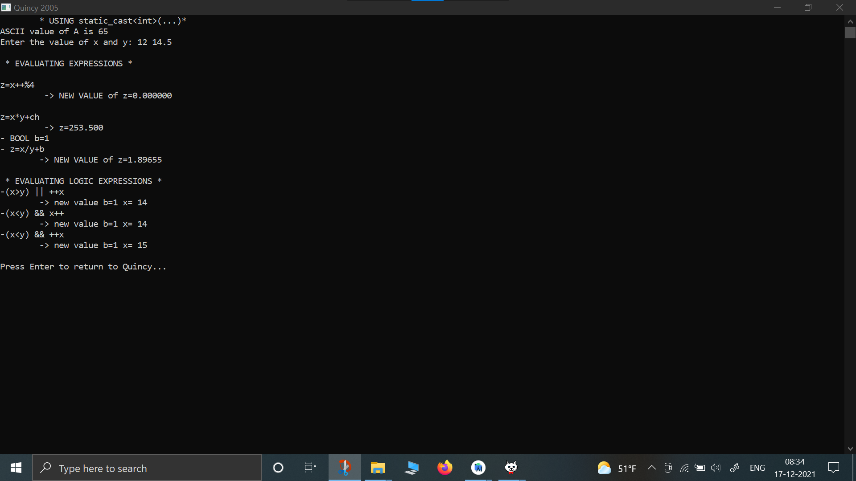

1. **WAP that shows if number is greater than or smaller than 20, also show if the number is divisible by 5 (nested if else statements):**

#include<iostream>

using namespace std;

int main(){

cout<<"\t__ NESTED IF-ELSE STATEMETS: __"<<endl;

for (int i=0; i<5; i++) {

int x;

cout<<"\nEnter a number : ";

cin>>x;

if (x<=20){

cout<<x<<" is smaller than 20"<<endl;

if (x%5==0) cout<<"\t-> "<<x<<" is multiple of 5"<<endl;

else cout<<"\t-> "<<x<<" is not multiple of 5"<<endl;

}

else cout<<x<<" is greater than 20"<<endl;

}

return 0;

}

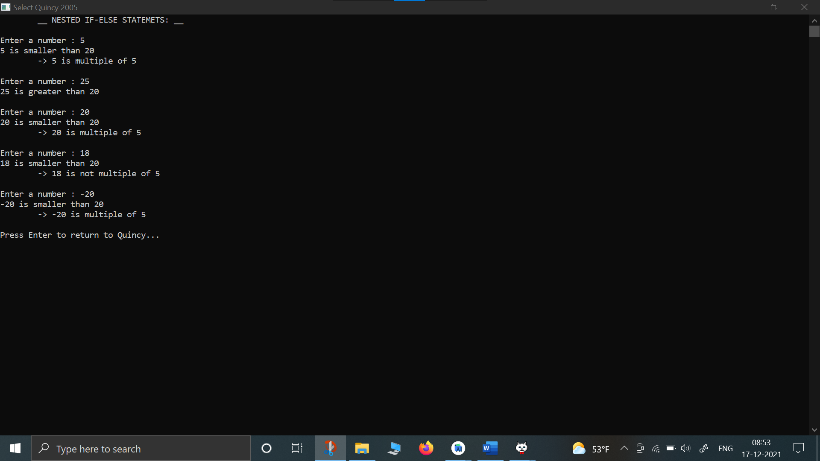

1. **WAP that compares two numbers input by the user and prints the greatest number:**

#include<iostream>

#include<iomanip>

using namespace std;

int main(){

cout<<setw(40)<<"__ * COMPARISION OF NUMBERS : C++ PROGRAM * __"<<endl;

float a,b;

cout<<"\nEnter the value of two numbers: ";

cin>>a>>b;

cout<<"\nThe numbers input by the user are "<<a<<" and "<<b<<endl;

cout<<setw(15)<<endl;

if (a<b){

cout<<b<<" is the greater number"<<endl;

}

else{

cout<<a<<" is the greater number"<<endl;}

}

return 0;

}

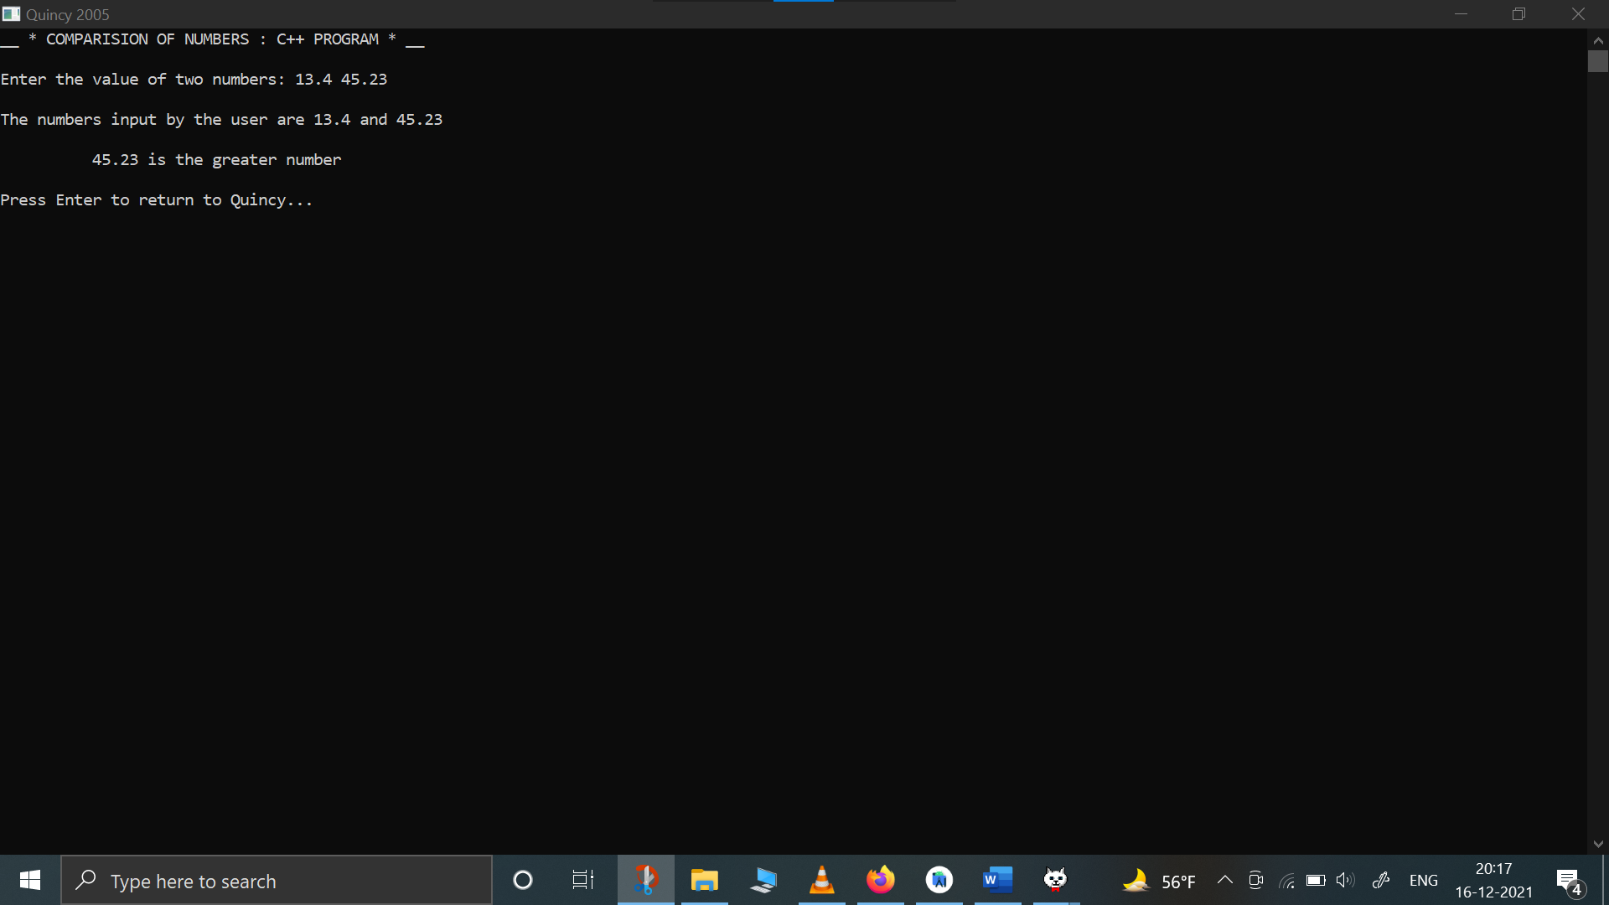

1. **WAP that compares 3 input integers and prints the greatest integer:**

#include<iostream>

#include<iomanip>

using namespace std;

int main(){

cout<<setw(50)<< "__*COMPARISION OF NUMBERS PROGRAM*__"<<endl;

char ch='p';

while (ch=='p'){

int a,b,c;

cout<<"Enter the value of three numbers: ";

cin>>a>>b>>c;

cout<<endl;

cout<<setw(25)<<"Maximum of three numbers is ";

if (a>b){

if (a>c) cout<<a;

else cout <<c;

}

else{

if (b>c) cout<< b;

else cout<<c;

}

cout<<"\n"<<endl<<"PROGRAM ENDS HERE"<<endl;

}

}

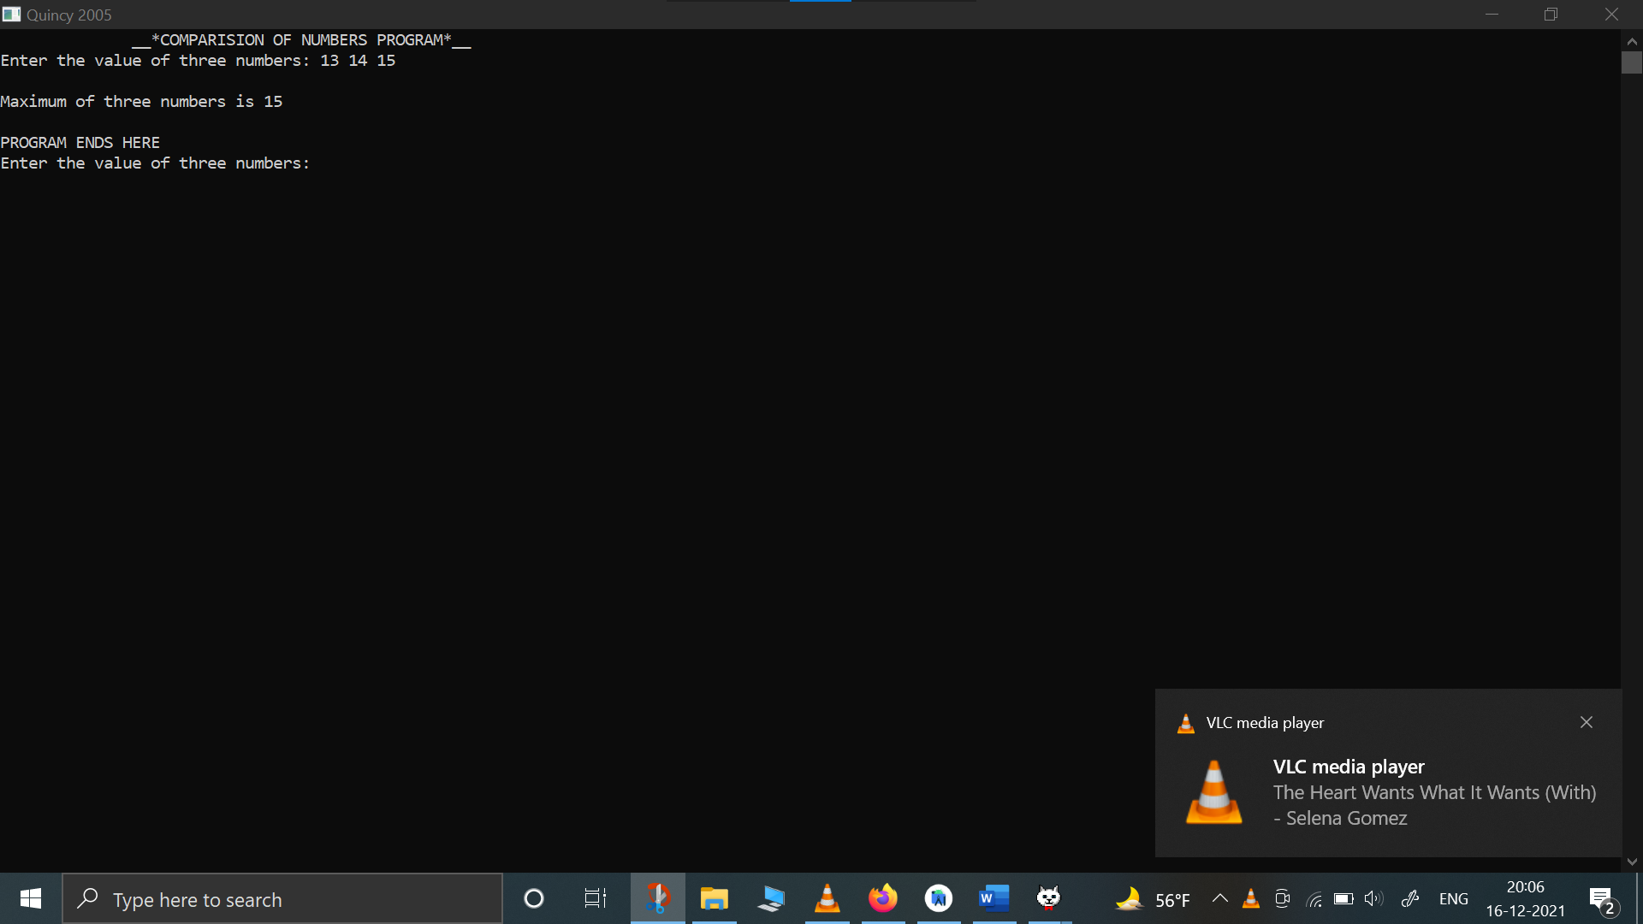

1. **Write a program that displays the greatest number out of n numbers entered by the user:**

#include<iostream>

#include<iomanip>

using namespace std;

int main(){

cout<<setw(40)<<"\n __* FINDING THE GREATEST NUMBER: C++ PROGRAM *__"<<endl;

float x;

int i,n,max;

cout<<"\nHow many numbers you want to enter? ";

cin>>n;

cout<<endl;

i=1;

max=-1;

while (i<=n){

cout<<"Enter the number : ";

cin>>x;

if (x>max) max=x;

i++;

}

cout<<"\n\tMaxiumum of "<<n<<" numbers is "<<max<<endl;

return 0;

}

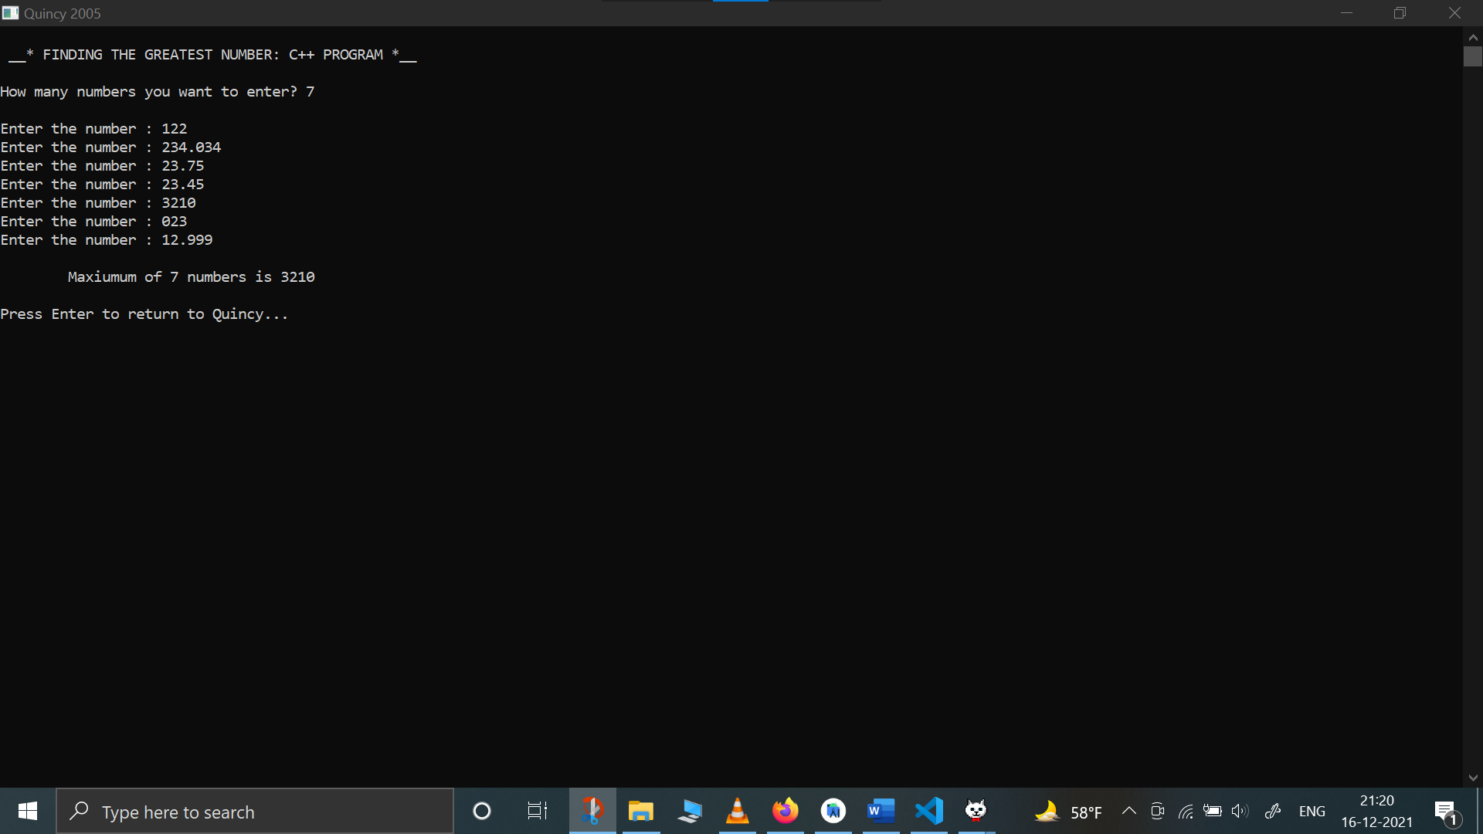

1. **WAP that shows the average of the numbers input by the user:**

#include<iostream>

using namespace std;

int main(){

int i,nums,x,sum,avg;

cout<<"How many numbers you want to enter? ";

cin>>nums;

cout<<endl;

i=1;

sum=0;

while (i<=nums){

cout<<"Enter the number : ";

cin>>x;

sum+=x;

i++;

}

avg=sum/nums;

cout<<"The sum of given numbers is "<<sum<<endl;

cout<<"The average of given numbers is "<<avg<<endl;

return 0;

}

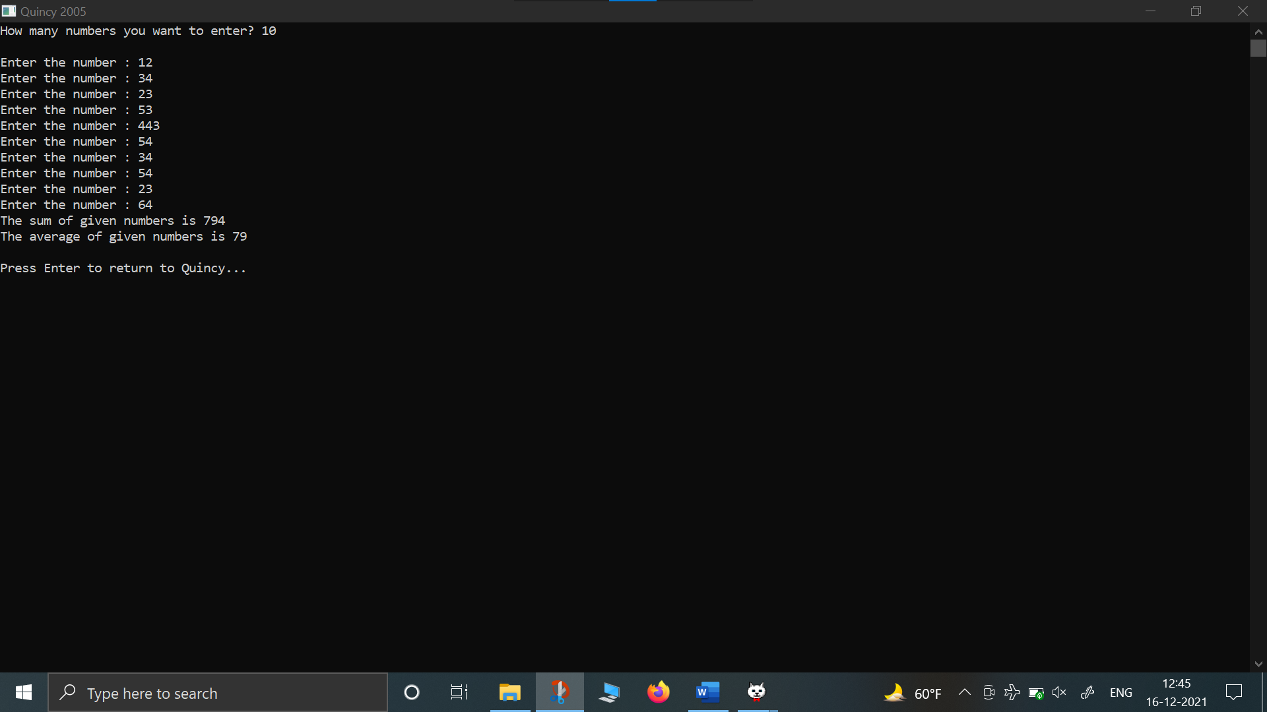

1. **WAP that only displays the even numbers entered by the user:**

#include<iostream>

#include<iomanip>

using namespace std;

int main(){

cout<<setw(50)<< "__* DISPLAY THE EVEN NUMBERS ENTERED BY USER: C++ PROGRAM *__"<<endl;

int i,n,x;

cout<<"\nHow many numbers you want to enter? ";

cin>>n;

cout<<endl;

i=1;

while (i<=n){

cout<<"\nEnter the number : ";

cin>>x;

if (x%2==0) cout<<"\t -> Even number is "<<x<<endl;

i++;

}

return 0;

}

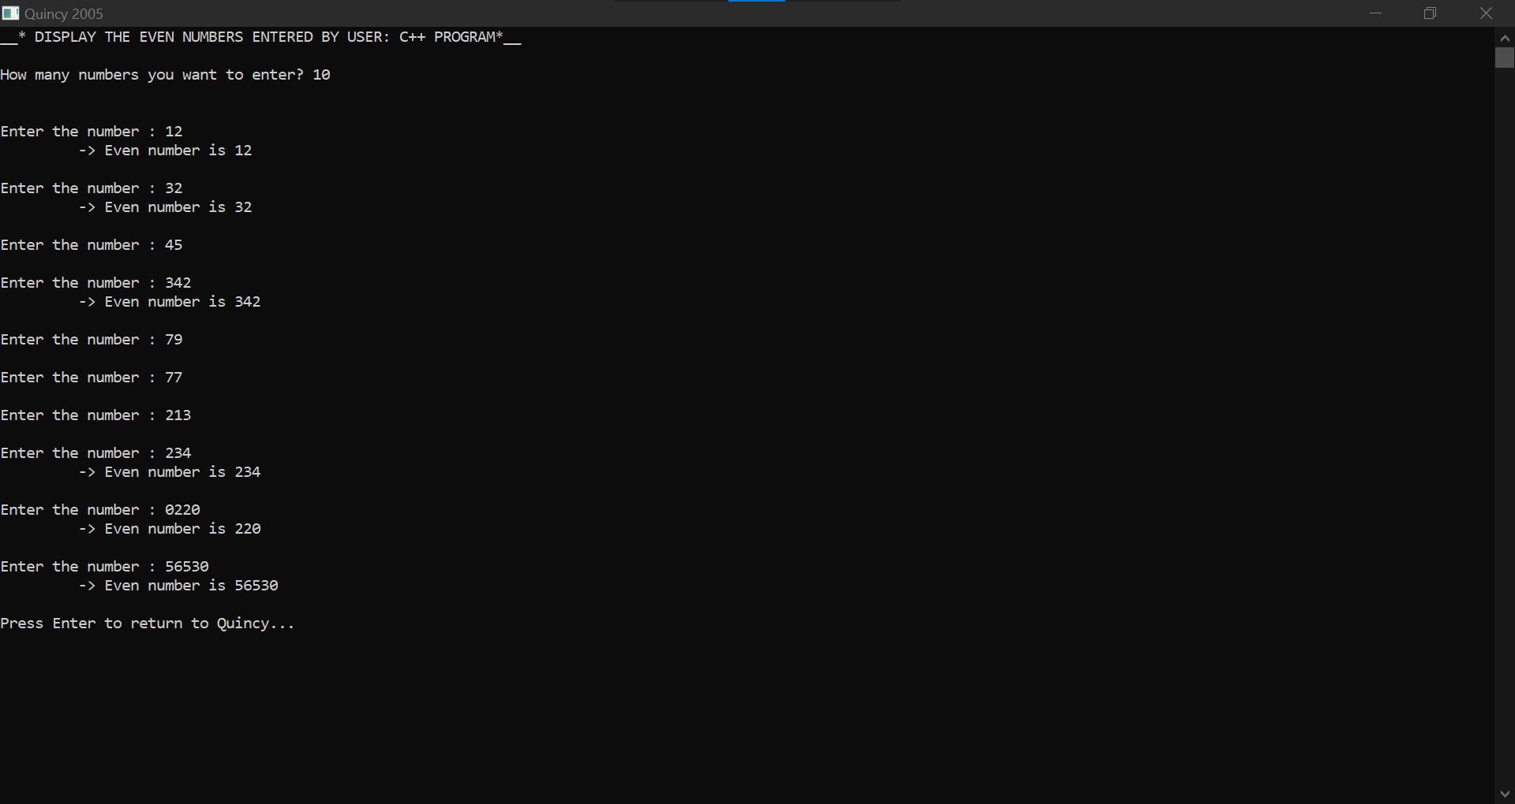

1. **WAP that only displays the odd numbers entered by the user:**

#include<iostream>

#include<iomanip>

using namespace std;

int main(){

cout<<setw(50)<< "__* DISPLAY THE ODD NUMBERS ENTERED BY USER: C++ PROGRAM*__"<<endl;

int i,n,x;

cout<<"\nHow many numbers you want to enter? ";

cin>>n;

cout<<endl;

i=1;

while (i<=n){

cout<<"\nEnter the number : ";

cin>>x;

if (x%2!=0) cout<<"\t ->Odd number is "<<x<<endl;

i++;

}

return 0;

}

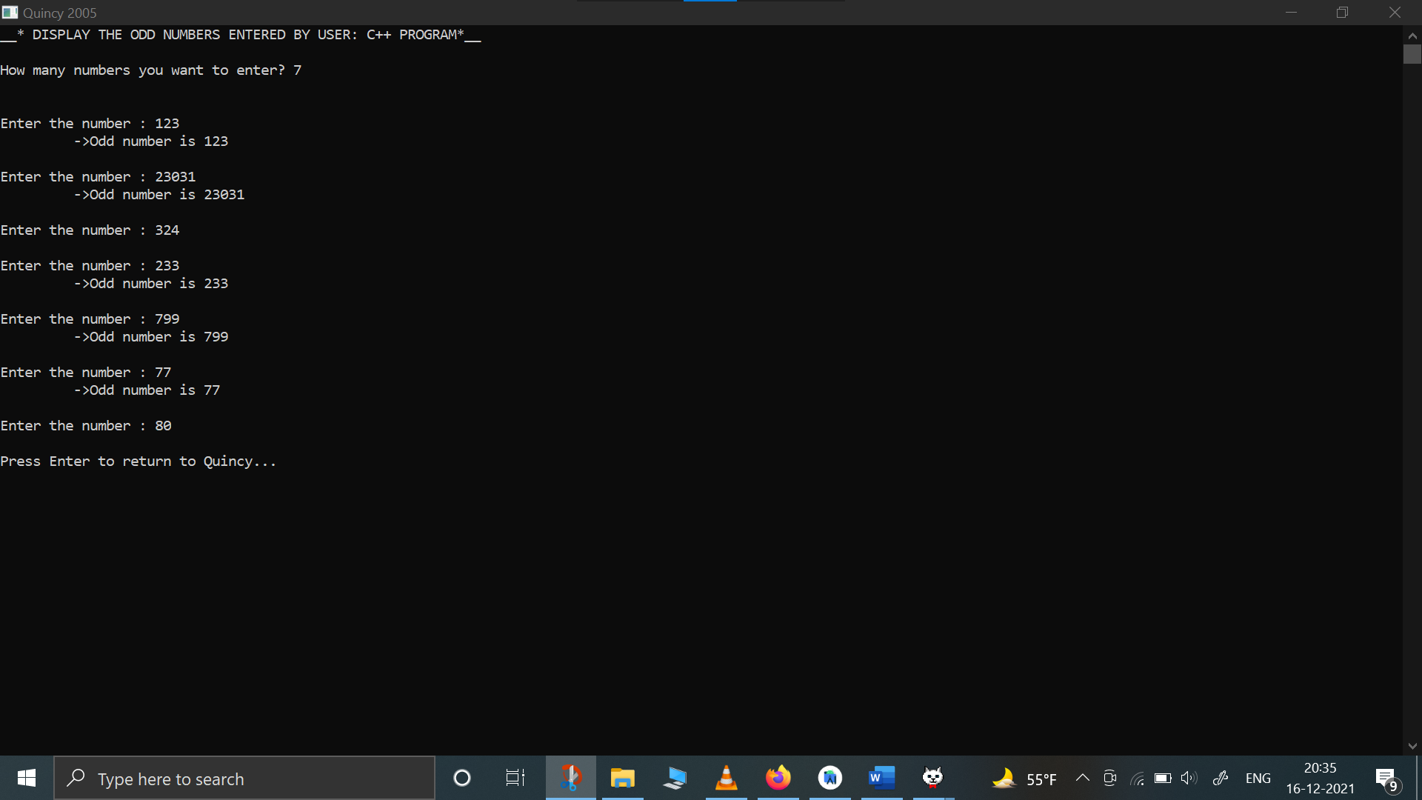

1. **WAP that only displays the sum of all the odd & even numbers entered by the user:**

#include<iostream>

#include<iomanip>

using namespace std;

int main() {

cout<<setw(60)<< "\n__* DISPLAY THE SUM OF ALL THE ODD & EVEN NUMBERS ENTERED BY USER: C++ PROGRAM*__"<<endl;

int i,n,x, sumOdd, sumEven;

sumOdd=sumEven=0;

cout<<"\nHow many numbers you want to enter? ";

cin>>n;

cout<<endl;

i=1;

while (i<=n){

cout<<"\nEnter the number : ";

cin>>x;

if (x%2!=0) {

cout<<"\t-> Odd number entered: "<<x<<endl;

sumOdd=sumOdd+x;

}

else{

cout<<"\t-> Even number entered: "<<x<<endl;

sumEven=sumEven+x;

}

i++;

}

cout<<"\n# SUM OF ODD NUMBERS IS "<<sumOdd<<endl;

cout<<"# SUM OF EVEN NUMBERS IS "<<sumEven<<endl;

return 0;

}

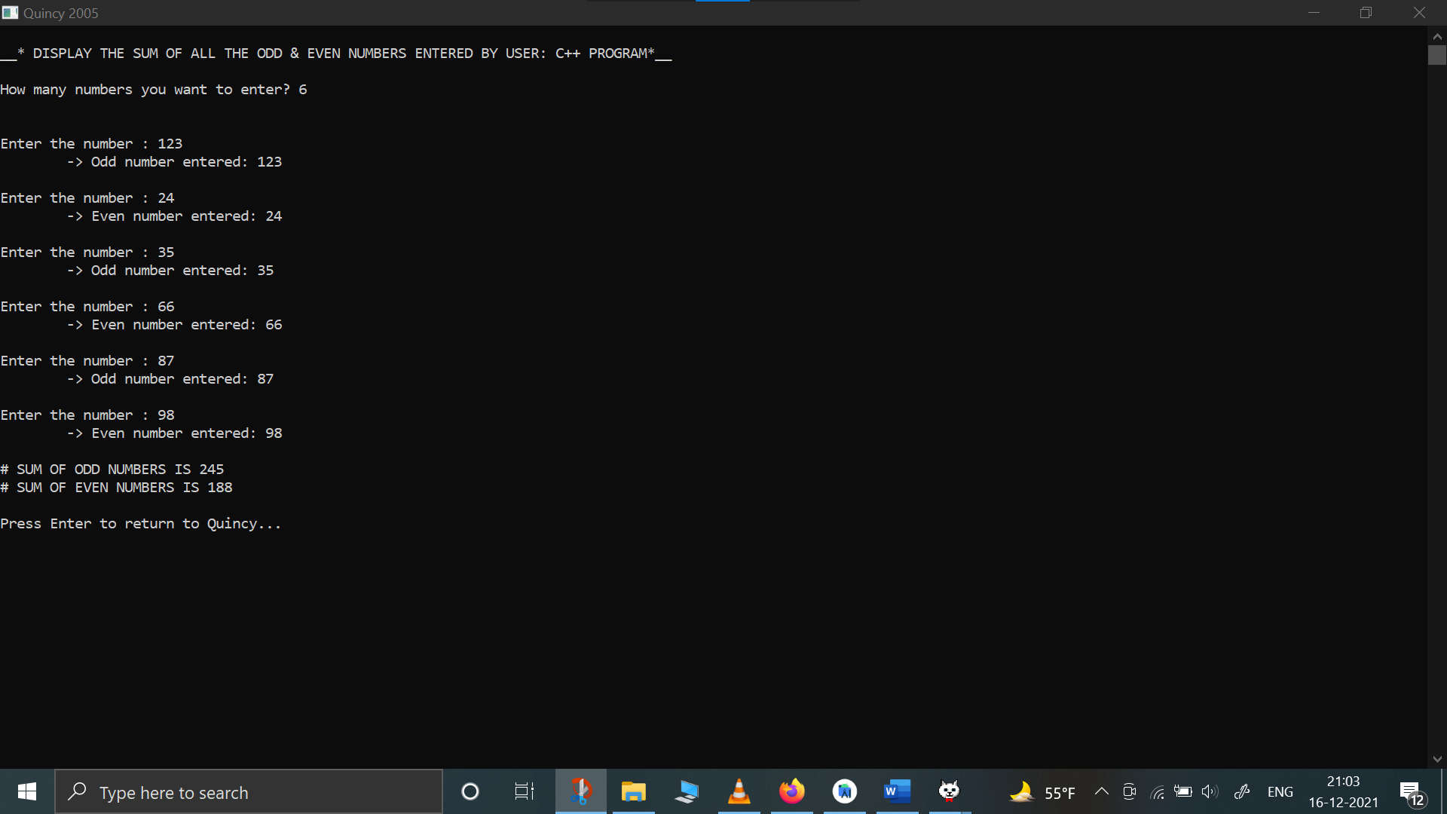

1. **Write a program that only displays the prime numbers out of the list of number entered by the user:**

#include<iostream>

#include<iomanip>

using namespace std;

int main(){

cout<<setw(40)<<"\n __* DISPLAY THE PRIME NUMBERS: C++ PROGRAM *__"<<endl;

int i,n,x,max;

cout<<"\nHow many numbers you want to enter? ";

cin>>n;

cout<<endl;

i=1;

while (i<=n){

cout<<"Enter the number : ";

cin>>x;

int k=2;

int flag=0;

while(k<x){

if (x%k==0) flag=1;

k++;

}

if (flag!=1) cout<<"\t-> Prime number entered: "<<x<<endl;

else cout<<endl;

i++;

}

return 0;

}

